Instructions for students on how to set up a GitHub account

Creating an account
Access GitHub website at https://github.com/
Click Sign Up button on upper right corner of the browser window

Enter your email and press continue
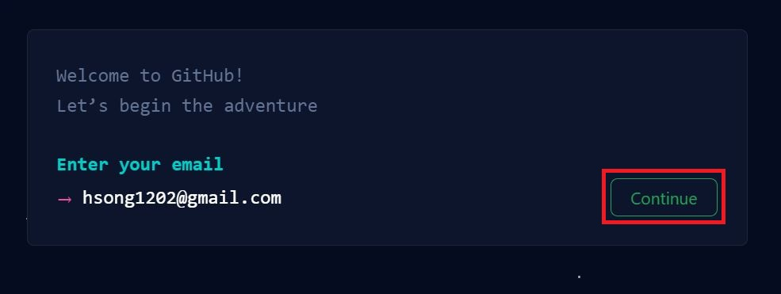
Create a secure password.
make sure it's at least 15 characters OR at least 8 characters including a number and a lowercase letter. Press continue
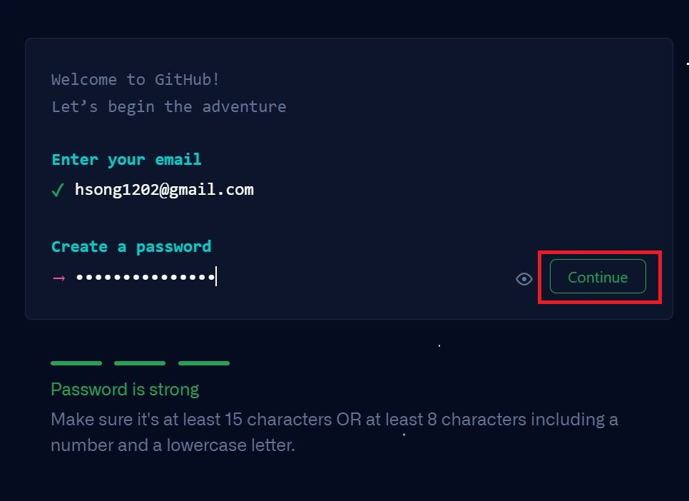
Enter a valid username
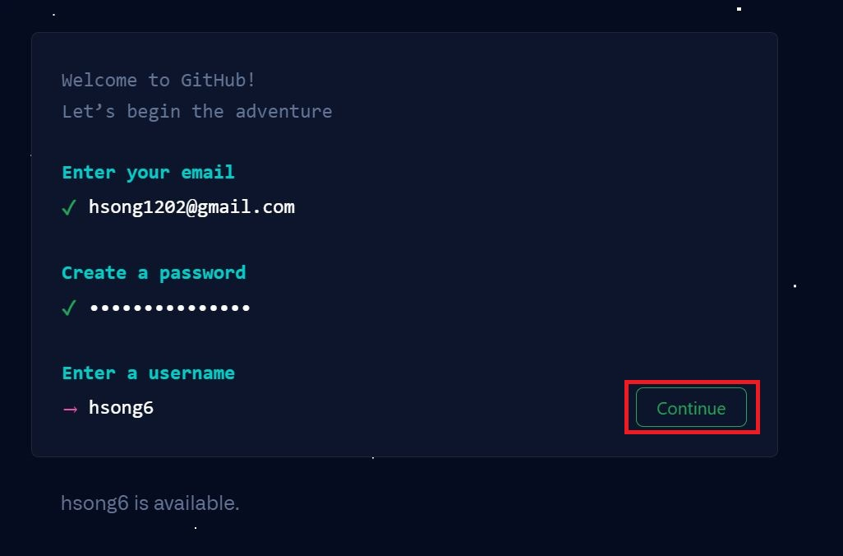
Press Continue
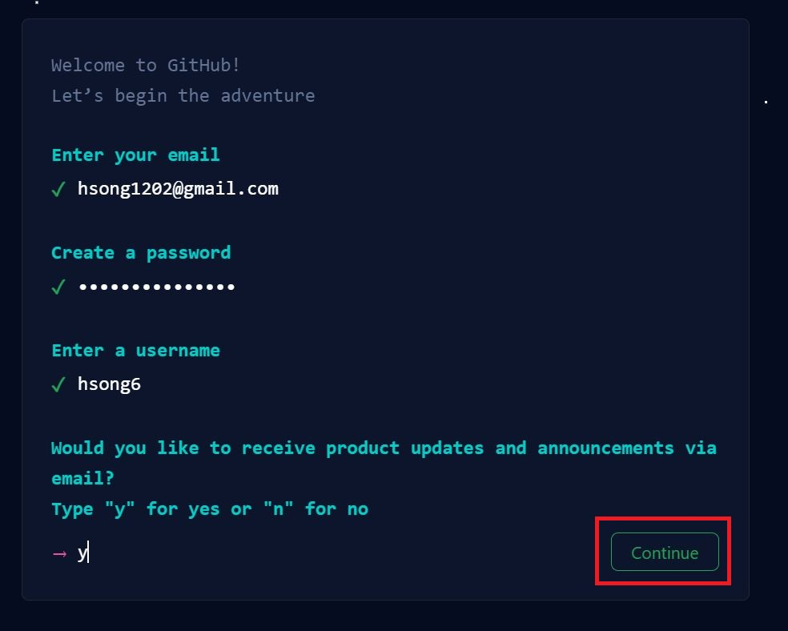
Press Continue
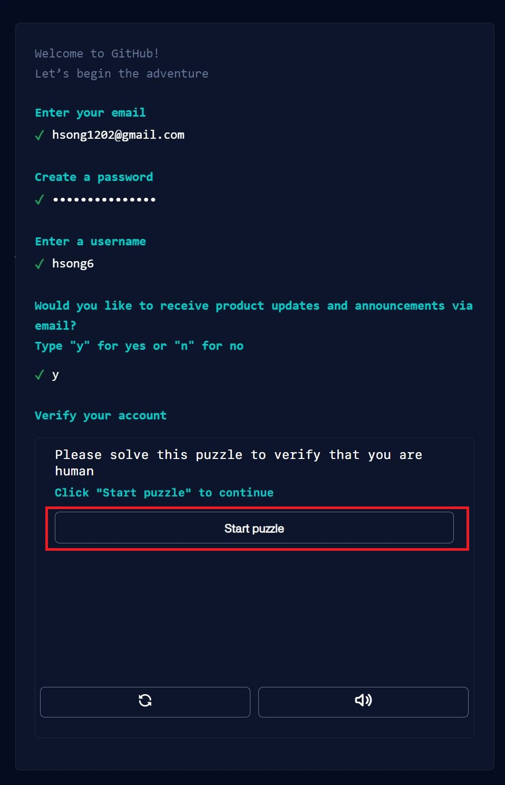
Start puzzle to solve Captcha
Press Create account
Check your email for verification number and submit it in the next screen.

Instructions for students on how to set up a GitHub Desktop for both PC and Mac

Following instructions can also be found in the link below:
https://docs.github.com/en/desktop/installing-and-configuring-github-desktop/installing-and-authenticating-to-github-desktop/installing-github-desktop
visit download page for the GitHub Desktop
https://desktop.github.com/
Following steps are intended for Microsoft Windows user with Windows 7 or higher and 64-bit operating systems.
Click Download for Windows.

In your computer's Downloads folder, double-click the GitHub Desktop setup file.

Following screen will appear

GitHub Desktop will launch after installation is complete.

Following steps are intended for Mac user with macOS 10.12 or later operating systems.
Visit the download page for GitHub Desktop.
https://desktop.github.com/
Click Download for macOS.

In your computer's Downloads folder, double-click the GitHub Desktop zip file.

After the file has been unzipped, double-click GitHub Desktop.
Following screen will appear
GitHub Desktop will launch after installation is complete.

